UPDATE 10-01-11 from Lsect


To receive these updates via email join at www.lsect.co.uk/join.asp
Please pass this information on to colleagues that may find it useful. Thanks.

YPLA response to Lsect update 24-12-10 (http://tinyurl.com/2u3rlfd)
I asked the YPLA funding team to review my last update, and they have provided a very helpful response. With permission I am publishing it in full here and below.

“Dear Nick,

Thank you for your invitation to speak at the 16-18 Funding Summit on the 8th February 2011 [visit http://tinyurl.com/37sq86h for more info) and I am pleased to say Jane Cowell (Director of Funding Policy) and Kevin Street (Head of Funding Development) will be happy to attend. We very much welcome your assistance with ensuring that the sector correctly understands the impact of the changes announced in our Funding Statement and as requested.

YPLA staff have reviewed your article. Although we can’t comment on your assumptions we would appreciate it if you could draw the attention of your readers to the following comments.

~ The 74% reduction in entitlement funding you calculate is technically correct we would want to point out that much of this reduction is returned to providers through the increases in provider factors (as the average programme weighting is corrected), the increase in programme size (as the SLN/Learner ratio is updated to 2009/10 levels) and the increased investment in disadvantage and ALS (of £150 million).

~ The comparison between learner numbers and budgets uses academic years for learner numbers and financial years for budgets.

~ You imply that the funding rate per SLN might also reduce. We recognise that this is possible if the overall level of recruitment exceeds our expectation however our current planning assumption is to use the current FE rate of £2,920.

~ The underlying reason why we have chosen to reduce the entitlement funding is because the efficiencies are required to absorb the increased cost of volume increases and unit cost increases as success rates and programme size rise, more learners from disadvantage backgrounds participate etc and to fund the re-investment in disadvantage and ALS. The efficiencies had to be made and reducing the entitlement was chosen because it protects the core qualification offer and gives providers the opportunity to reduce activity rather than trying to continue delivering the same activity on less funding.

~ The allocations methodology only creates an envelope of funding. Once funding is allocated to providers then what activities are delivered are entirely at the providers’ discretion. Therefore the activities providers’ and learners value and that work, can continue.

~ Although all the policy changes are being implemented in 2011/12 Transitional Protection will prevent any provider from losing more than 3% in funding per learner in 2011/12. This is deliberate so that once providers have their allocation statement in March they will be able to see the level of funding per learner they will receive in 2014/15 (should all other elements stay the same) and be able to commence strategic planning to reduce their cost base to deliver within this funding level, including through collaboration or other methods. Your spreadsheet will no doubt help providers assess this level however we would point out that column K is not the level of funding for 2011/12.

I hope the above is helpful and we look forward to working with you to support the sector to understand the implications of the funding changes.

Kind regards,

Jane Cowell, Director Funding Policy, YPLA”

YPLA funding slides and commentary
The YPLA are currently briefing colleges on the funding changes, and have supplied a few of their slides with some very useful commentary (quoted in full).

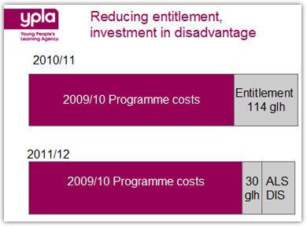
This slide demonstrates that the CORE PROGRAMME is actually
increasing because we are re-basing the SLN:LN ratio to 09/10 actual delivery.

The additional entitlement is being reduced down to 30 glh from 114 glh.

Further funding of £150m is being reinvested in ALS and disadvantage to
support the Government’s priority to fund the most disadvantaged learners

Many providers have asked why 30 glh and not say 36 (1 hour per week)
The reason is affordability. 30 glh is all that can be afforded come 2014/2015
if we went with 36 we would have to have another cut somewhere else.

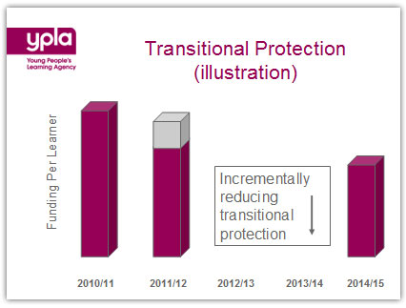
~ We are making all the policy changes in 2011/12
~ In essence this means that funding per learner will drop immediately to 2014/15 levels
~ Then this is protected by a max 3% reduction for 2011/12
~ For the remainder of the CSR period the TP (Shown on the slide in light blue) will be removed incrementally.
~ I must stress that there is not a final profile for this reduction yet but we do intend there
to be no TP in 2014/15 so you can plan accordingly.

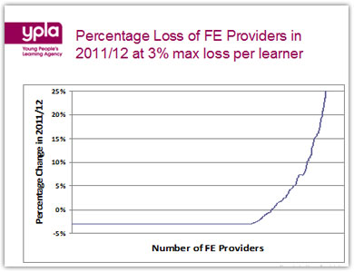

This slide demonstrates the percentage loss for all FE providers in 2011/12 ONLY
because of the TP
No provider will lose more than 3% of its total funding per learner.
We estimate that of the 770 total FE providers:
~ 507 will lose 3% per learner
~ 56 will lose between 3% and 0%
~ 206 will see an increase.
Increases will not be capped and therefore rises will be seen in full.
This will particularly benefit those providers who have voluntarily grown the size of their programme without being funded for it

YPLA/SFA funding briefings by Nick Linford – places available
Want to find out more and get your questions answered? Places remain available for the 18th of January in Solihull (click here: http://tinyurl.com/2vytqzk) 25th January in London (click here: http://tinyurl.com/2uym3kh). These are short but focussed sessions, both on the key announcements and implications for 2011/12 in the YPLA 16-19 Funding Statement and Skills Funding Agency Guidance Note 6.

16-18 entitlement funding article
You may have seen this article in the FE Focus on Friday, in which my estimates were quoted. If not, you can read it online here: http://tinyurl.com/35aklu6

2011 Lsect Happiness Survey
The interim results of this survey can be seen here (http://tinyurl.com/32yzcrw). However, it is still taking responses, so if you have not already done so please take a minute (only two mandatory check-box questions) to complete it here: http://tinyurl.com/3aaq75z%20

Kind regards,

Nick
www.twitter.com/nicklinford

P.S. You’ll be pleased to know I’ve begun the post-Christmas fitness drive in style. Check out my new set of wheels! http://twitpic.com/3o5z4f

